Donor Email Templates
Below is customizable text and copy for four donor emails, with banner images sized accordingly. Here is an overview of what is included:
- Welcome
  - 1a. Workplace campaign kickoff
  - 1b. Company CEO welcome
- Reminders
- Thank You (post- campaign)

Phase 1: Welcome
Email 1a: Campaign Kick-off
From: Your United Way CEO
Audience: All company employees
Header:
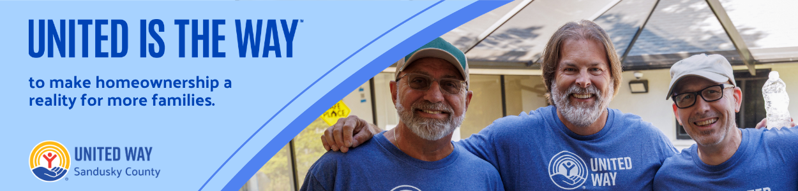
Subject Line: United is the Way to strengthen Sandusky County.
Email Body:
[NAME],
Every day, people across Sandusky County are helping make our community stronger. Volunteers are mentoring students. Families are finding the support they need during difficult times. Seniors are receiving services that help them remain independent. Children are entering kindergarten ready to learn.
Those successes don't happen by chance—they happen because our community chooses to come together.
That's what United Way is all about. We bring people, businesses, and local nonprofits together to solve our community's biggest challenges. When we all give a little, together we accomplish a lot.
Today, we're kicking off our annual United Way campaign, and we're inviting you to be part of the difference. Whether it's your first gift or you've been giving for years, every contribution helps strengthen programs and services that make Sandusky County a better place for all of us.
Donate today and join us in creating more opportunities for our neighbors to thrive. Together, we can accomplish more than any one of us could alone—because United is the Way™.
Best Regards,
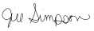
Jill Simpson
CEO/President
United Way of Sandusky County
director@uwsandco.org

Email 1b: Company CEO Welcome
From: Company CEO, Leader, or Employee Campaign Chair’s first and last name
Audience: All company employees
Header:
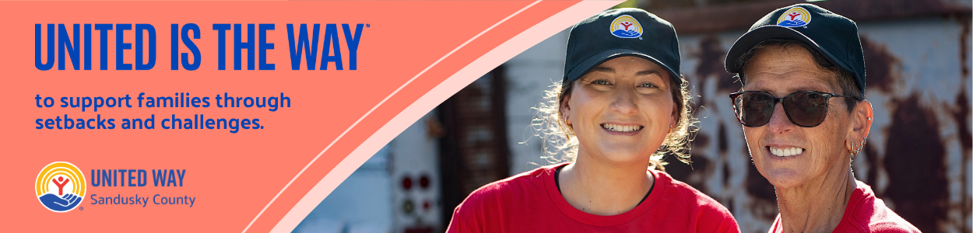
Subject Line: [Company Name] Team, please join me in supporting our neighbors in Sandusky County.
Email Body:
At [COMPANY NAME], we believe in giving back to the communities where we live and work. That’s why I’m proud to support our friends at United Way of Sandusky County– and I’m inviting you to join me.
Every day, United Way – with the support of community-minded partners, volunteers, and donors like us – is working hard to ensure that everyone has access to essential services and resources they need to thrive, including:
- Nutritious food and access to quality health care our neighbors need to lead healthy lives.
- Childcare, early learning, education, and enrichment to set kids up for success from cradle to career.
- Counseling, career training, and housing support to help families not only make ends meet, but create a sustainable financial future.
- Emergency preparedness and disaster recovery efforts to ensure that our community stays connected, strong, and resilient, no matter what challenges we may face.

Please consider making a one-time or recurring gift to support this powerful work and send a message of solidarity and compassion to our neighbors most in need. Together, we can make a transformative impact on our community.
United is the Way™.
Thank you in advance for your generous support.
Sincerely,
[CEO Name]

Phase 2: Reminders
Email 2: Reminder – United Way’s Impact
From: Your United Way CEO
Audience: All company employees
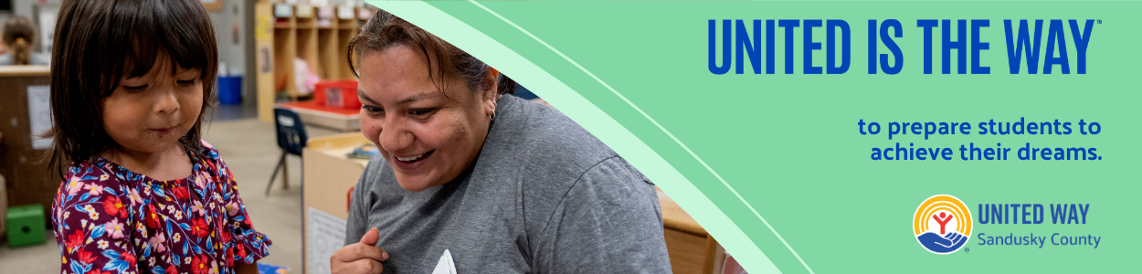
Subject Line: What is United Way doing for the Sandusky County community?
Email Body:
[NAME],
United Way of Sandusky County has always been about neighbors helping neighbors: a legacy of generosity and impact spanning almost 96 years. Every day, we see firsthand how our community comes together to support one another, creating opportunities and hope for local families.

Thanks to the generosity of donors, volunteers, and community partners, your support is creating real change right here at home. Last year, United Way of Sandusky County investments helped:
- 2,455 young people participate in positive youth development programs.
- 123 local residents receive financial assistance while undergoing cancer treatment.
- 66 individuals find permanent housing.
- 2,496 people receive help meeting basic needs such as food, utilities, and emergency assistance.

Every gift, no matter the size, helps create opportunities for our neighbors and strengthens the programs our community depends on.
If you’ve already made a one-time or recurring gift this year, thank you for being part of our community-led movement for good. If you haven’t, we hope you’ll consider giving by the [DATE] campaign deadline.
A better future is possible when we work together to achieve it. United is the Way™ we can make Sandusky County a community where everyone has the chance to thrive.
Best Regards,
Jill Simpson
CEO/President
United Way of Sandusky County
director@uwsandco.org

Phase 3: Thank You

Email 3: General Thank You to All Employees
From: Your United Way CEO
Audience: All company employees

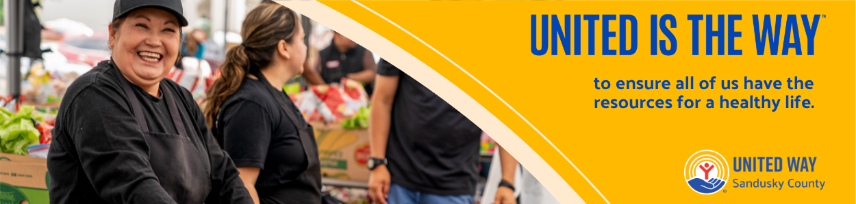

Subject: [COMPANY NAME], thank you for your impact!
Email Body:

Dear [NAME],
Join me in celebrating the success of the 2026 [COMPANY NAME] United is the Way employee giving campaign.
I’m thrilled to report:
• [COMPANY NAME] employees gave $ [DOLLARS PLEDGED] to United Way of Sandusky County
• [PARTICIPATION RATE%] of [COMPANY NAME] Employees gave to United Way of Sandusky County
• [NUMBER OF DONORS] of [COMPANY NAME] employees gave to United Way of Sandusky County

Let’s continue changing lives and transforming communities in Sandusky County!

United is the Way™.
With gratitude,
Jill Simpson
CEO/President
United Way of Sandusky County
director@uwsandco.org

